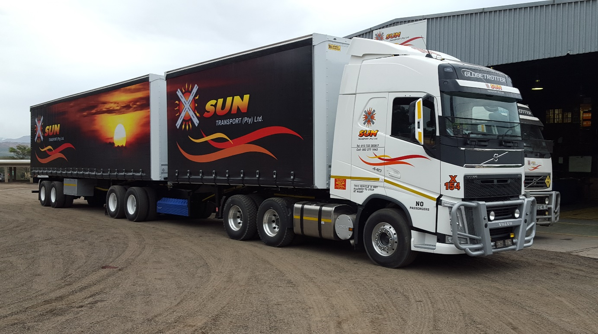



**COMPANY**

PROFILE

**2016**

**POSTAL ADDRESS: PO BOX 15101, NELSPRUIT, 1200**

**DEPOT AT: ALKMAAR, NELSPRUIT, 1201**

**TEL: (013)**

**733 3036/7**

**FAX: (013) 733 3038**

**DIRECTORS**

**:**

**MM Pohl, HA Pohl, PW Fynn**

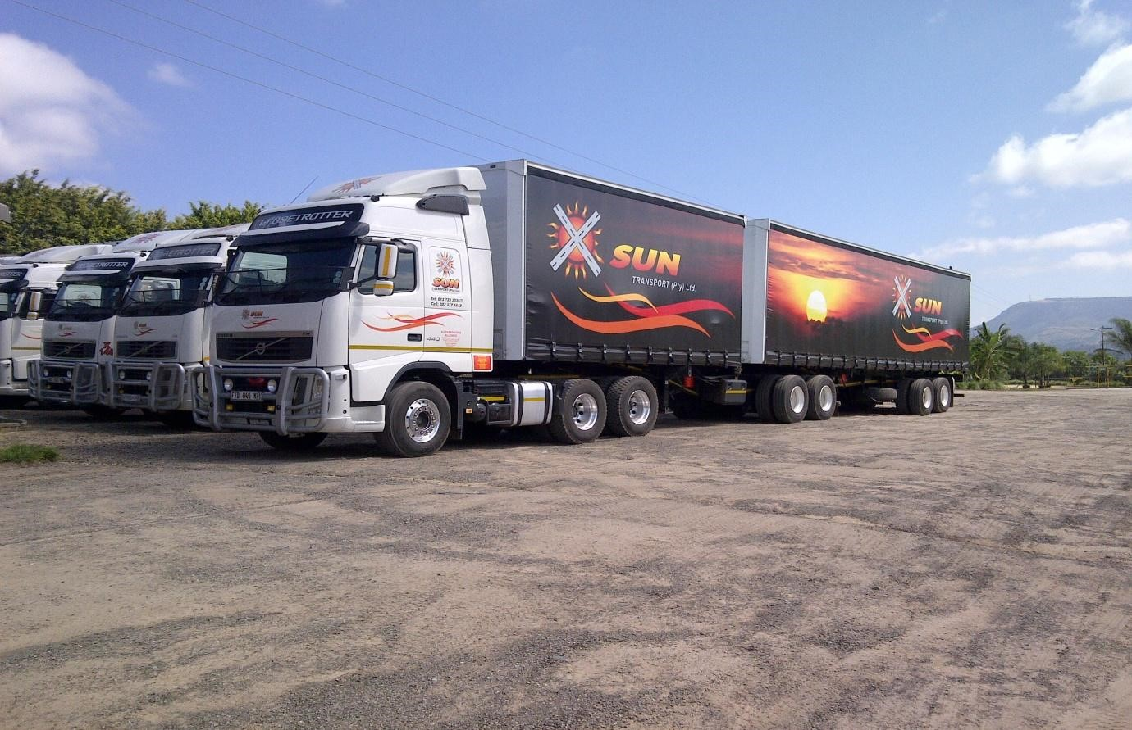

X

-

SUN TRANSPORT (PTY) LTD

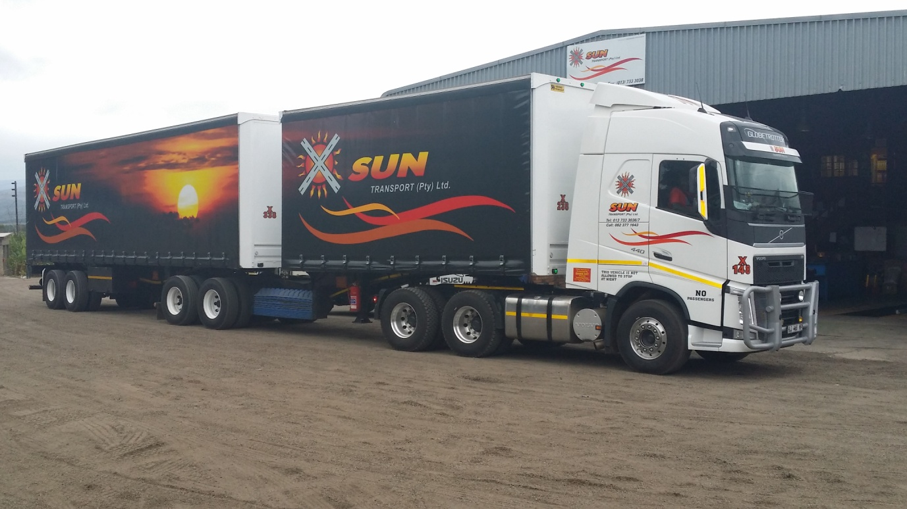

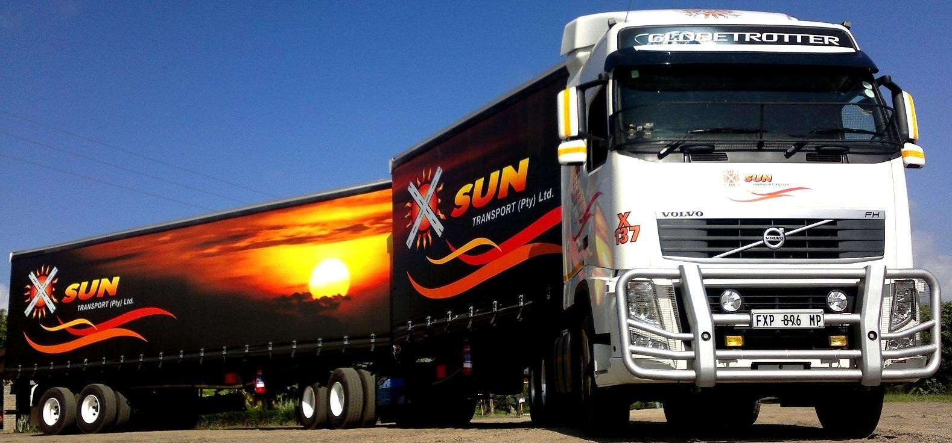

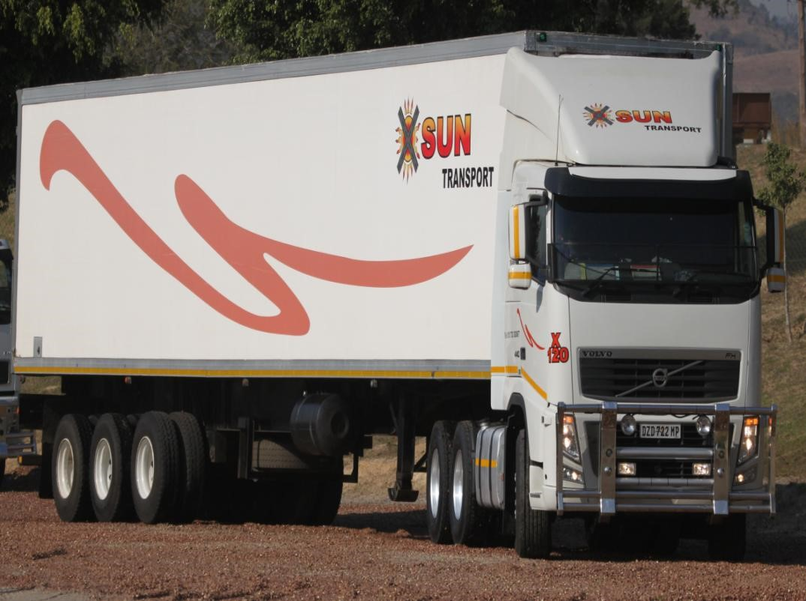

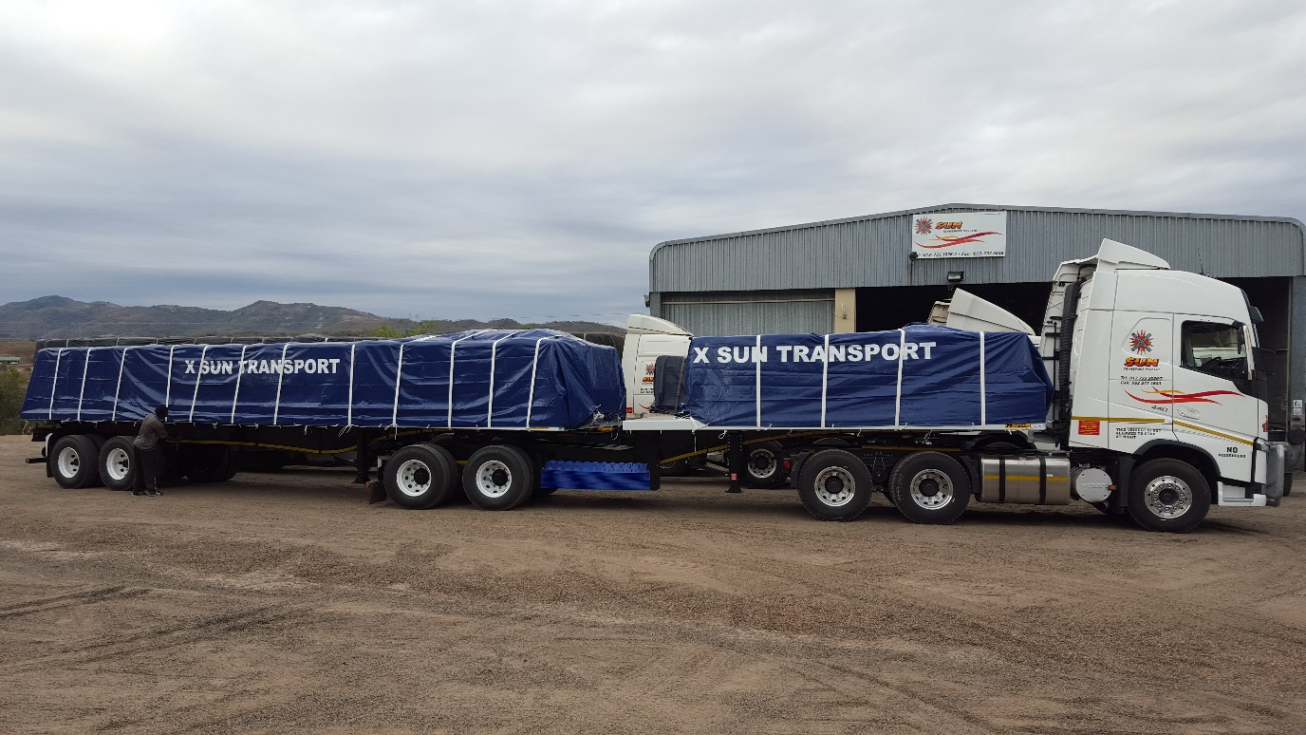

**X-Sun Transport Profile**

**Index**

* Ability, Experience

* Establishment

* Mission

* Key Performance Area’s

* Current Contracts

* Current Operational Capabilities

* Sub Contractors

* Operations Organogram for destinations

* Replacement Policy

* Location and Facilities

* In Transit Communications

* Terms and Condition

* P.O.D Management

* Current Information Systems

* Fuel Levy

* Goods in Transit Insurance

* Comprehensive Vehicle Insurance

* Vehicle Specification and Equipment

* Driver Training and Performance Standards

* Health Care

* Anti-Hijacking Procedure and Devices

* Breakdowns

* Customer Liaison & Service

* Standards

* Road Transport Management Systems

* Black Economic Empowerment Initiatives (Annexure D) Thank you for the opportunity to provide you with our Company Profile.

# Ability, Experience

Harry & Daleen Pohl were working for the Sunripe Transport Group for almost ten years.

In 1993, Sunripe merged with the Imperial Group, and by the end of 1994, Long Distance Transport was the newest addition to the group.

Harry Pohl was involved with Sappi as a transport contractor since 1994 with 20 years paper, pulp, waste, chemicals and other raw materials experience.

As Depot Manager at Long Distance and Gold Fields Logistics , Harry Pohl was responsible for all refrigerated and flatbed transport in the Mpumalanga area focussed on the Sappi contracts.

# Establishment of X-Sun Transport in August 1999

Harry & Daleen Pohl, in conjunction with Sandra Du Randt from Jackson Transport, decided to form an Mpumalanga based Transport Company.

X-Sun Transport was established mainly to cater for broking in flatbed and refrigerated transport.

With the company growth they were able to buy their first truck and super link trailer in February 2000.

X-Sun Transport moved to Alkmaar depot in January 2000 and bought the property in 2003. The depot is situated 20 km outside Nelspruit on the N4 toward Sappi Ngodwana (30km).

Since its establishment, X-Sun Transport has grown to over 72 employees.

# Our Mission

We believe that it is possible to transport anything under the sun from A to Z and strive to deliver dedicated serves with every load. Our reliability adds value to our clients and their products.

Our pledge to all our valued clients

With teamwork between Transporter and Client, we strive to build years of good business relationships with our valued clients. From starting point up to delivery point we strive to deliver cost effective and efficient operations to you benefit.

# Our Key Performance Area’s

These performance areas will assure you of our dedicated services.

* Trucks on time, reliability
* Communication between Operations, Driver and Client
* Complaints handled and solved to client satisfaction
* Administration, - P.O.D’s are processed and accompanied with invoices as required by the client needs
* Operations feed back during transport from loading till off-loading. Notice of any delays, breakdowns, etc.

# Current Contracts

We have annual renewed contracts with:

- Sappi

- TSB.

Our cross border work is currently paper loads into Swaziland and sugar out of Swaziland.

Registration specific barcodes were implemented on our trucks as required by Sappi. This is, to scan the trucks on their system for tracking of loads.

# Current Operational Capabilities

34 x 6X4 Volvo's truck tractors

1 x 6X4 Volvo truck tractor with a 13m tri-axle trailer (Sappi shunter)

1 x Nissan truck tractor with a 13m tri-axle trailer (Depo shunter)

17 x Super link flatbed trailers

15 x Super link taut liners

3 x Refrigerated trailers

The long distance fleet trucks range between 2011-2016.

The super link trailers range between 2011-2016.

The total tare mass of all the combinations are below 20 000 kg.

# Sub Contractors

We have four permanent sub contractors with X-Sun Transport branding.

**Operations Organogram**



**Refrigerated Transport**



**Flat Bed**

**/Taut Liner**

**Transport**



**DESTINATIONS**



**DESTINATIONS**



Johannesburg

-

Pretoria



Bloemfontein

-

Welkom



Cape Town



Durban

-

Pietermartizburg



Klerksdorp



Johannesburg

-

Pretoria



Bloemfontein



Letsitele



Durban

-

Pietermartizburg



Swaziland



Nelspruit



Rustenburg



Cape Town



**Other destinations:**

**Ad**

**-**

**h**

**oc Basis**



Port Elizabeth

# Replacement Policy

X-Sun Transport replacement policy for long haul trucks is every four years, or 850 000 km, whichever comes first.

# Location and facilities at the depot

X-Sun Transport’s depot is situated 20km outside Nelspruit on the N4 towards Sappi Ngodwana (30km).

Diesel facilities.

Wash bay – to wash trucks & tarpaulins on regular basis to ensure clean trucks at all times. Maintenance and repairs are carried out in our well equipped workshop. All work carried out is Volvo approved and electronics are done by V-Cads Program (Volvo laptop).

Four Mechanics on 24-hours standby.

Fully equipped breakdown vehicle.

Tyres and maintenance.

Maintenance of tarpaulins on monthly basis per trailer, although spare tarpaulins are available when needed.

Control / Training of Drivers.

# In Transit Communication

All our trucks in are equipped with cellular phones that enable us to maintain regular contact with our drivers on all major routes. Should you at any stage, wish to know the whereabouts of a specific vehicle, kindly contact our operations department for assistance.

Each truck tractor is fitted with a satellite tracking system, Mix-Telematics, for control, monitoring and tracking any moment of the day. It allows for real time location of any vehicle in the fleet.

Our drivers will notify us immediately of breakdowns and any other delays, which they may experience at the loading or off-loading points.

# P.O.D Management

P.O.D’s, are handed in by drivers on a daily basis and checked by operations at the X-Sun Transport Depot, where documents are matched with specific route numbers, signed and passed on for processing purposes.

Invoices with P.O.D are sent to customers on completion.

Invoicing can be provided electronically.

**Terms and Condition**

30 Days of Statement date.

# Current Information systems

* *Transport System*

**In-house system “Transport” has been written specifically for X-Sun Transport that allows the following:**

Capture all P.O.D’s

Determine loads per month per truck as well as destinations

Average turnover per truck per month Average tonnage per truck per month Diesel consumption per truck, etc.

* *Fuel Manager System*

All orders and suppliers invoices are controlled thought this system. Diesel transactions are captured and diesel consumptions per truck are calculated. Our Stock is also controlled through this system.

* *Financial System*

Pastel

VIP

Mix-Telematics Tracking System

# Fuel levy

All transport rates are subject to changes in the fuel price, which are subject to change on the first Wednesday of each month (as released by the Department of Minerals and Energy).

# Goods in Transit Insurance

Our Insurer : Associated Marine, a Division of Santam

Cover : All Risk Basis

Monthly policy including Sasria

Load limits:

Reefer @ R1 500 000.00

Taut liners @ R1 500 000.00

Flatbed @ R1 250 000.00 (incl. Vat)

A copy of our GIT confirmation is attached.

# Heavy Commercial Vehicle Insurance

Our Insurer : Guard Risk Insurance Company, Administered by Captive Business Consultants

Comprehensive Fleet Insurance

Monthly policy including Sasria

Included R2 500 000.00 Third Party Liability extended with a further R7 500 000.00.

Extended Third Party Liability for Swaziland @ R2 500 000.00.

Included Drive Report Management,

Danie Day Private Investigators for theft and hi-jacking incidents, KVTR – Road Constructions of accident scene.

# Vehicle Specification and Equipment

All our super link trailers specifications are 6m x 12m combinations, and are capable of legally conveying 36-ton payloads.

Our vehicles are equipped with all the necessary protection equipment to ensure the safety of products.

This includes:

Tarpaulins and flysheets – inspected regularly for damage and cleanliness.

Ensure maximum load protection in weather conditions.

Ropes on tarpaulins are replaced with inspection to ensure that they are clean.

Load straps – replaced and washed on a regular basis, and extra load straps are available on each truck should any strap break.

Corner plates – two available per strap.

Rubber straps on the deck.

Paper savers as per Sappi’s specifications.

# Driver Training and Performance Standards

Our company places the utmost importance on driver selection and training.

The selection includes medical fitness and previous professional driving experience.

All new employed drivers attend a Volvo training program before operating a truck tractor.

Truck drivers attend an update Volvo training program every 6 months.

Volvo South Africa gives every truck tractor driver an evaluation certificate.

In-house training is used to update drivers on customer requirements, basics of mechanic and security issues to eliminate unnecessary downtime on minor breakdowns.

The above training is vital to road safety, and the safe conveyance of our customers’ cargo.

To ensure our drivers perform to high standards, vehicles are fitted with taco graphs enabling management to analyse and monitor driving techniques, performance, arrival and departure times, speed, etc.

Employees are trained on a regular basis, through performance management. A Labour Consultant Company is used for HR Training.

# Health Care

All drivers are bounded for medical examinations annually.

Certified letter kept on record as required by RTMS (Road Transport Management System).

# Anti-Hijacking Procedures and Devices

All trucks are equipped with Mix-Telematics and Tracker Systems, which ensure tracking of vehicles at all times.

Systems are tested every week at the depot to enable accuracy in case of hi-jacking.

A satellite tracking system is installed in all trucks, which allows operations to control vehicles via the Internet. Real time data is available, e.g. time vehicle left customer, time of arrival at customer, in transit tracking, etc.

# Break Downs

X-Sun Transport have four Mechanics (two at depot and two on road assistance), 24-hours on standby in case of a breakdown.

Fully equipped breakdown vehicle is available for road side assistance.

Communication between driver, mechanics, operations and customers’ representatives is essential.

In the event of breakdowns of a serious nature, a replacement vehicle will be made available to prevent delays.

# Customer Liaison and Service

We have personnel available to ensure that any problem which occurs can be resolved quickly and efficiently.

We maintain personal contact with all clients at loading and off-loading points to ensure that we continue to provide a service of consistently high quality and standard.

# Standards

X-Sun Transport believes in high standards and quality, thus we adhere to standards such as OHSACT, Employment Equity Act, Road Transport Management System, etc.

All parts replaced are SABS specified parts recommended by vehicle suppliers.

**RTMS** (Road Transport Management System)

We obtained RTMS accreditation in Oct 2014. We are also continuously being audited by Imperial(Lafarge)

This system is a voluntary self regulation scheme that encourages consignees engaged in the freight logistics value chain to implement this recommended practise that contributes to the preservation of roads

Infrastructure improves road safety and increases the productivity of the logistics strategy.

# Broad Base Black Economic Empowerment Initiatives (“BBBEE”)

Level 6

See Attached documentation

......................................................

Mr. H. A. Pohl

Managing Director

082 413 6820